
ICT302 IT Professional Practice Project
Project Name:
Secure QR Code Development
Client Organization:
Secure QR Code Project Client
Group Name:
VAFPQR
Requirements and Analysis
Submitted by:
Lim Yu Jun Felixia [35544256]

Submitted to: LMS
Submitted on: 8 June 2026
Version: 1.0

Table of Contents
1. Executive Summary 3
2. Introduction 3
2.1 Purpose of the Project 3
2.2 Background 3
2.3 Problem Description 3
2.4 Opportunities 4
2.5 Project Objectives 4
2.6 Development Methodology 4
3. Proposed Solution Outline 5
3.1 Solution Overview 5
3.2 Project Scope 6
3.3 Constraints 6
3.4 Hardware and Software Environment 6
4. Functional Requirements 7
4.1 System actors 7
4.2 Functional requirements matrix 8
5. Non-functional Requirements Security Requirements 13
5.1 Performance Requirements 13
5.2 Reliability Requirements 13
5.3 Availability Requirements 13
5.4 Compatibility Requirements 13
5.5 Usability Requirements 13
5.6 Maintainability Requirements 13
5.7 Assumptions 14
6. Diagrammatic Representation of the Requirements 15
7. Conclusion 17
8. Appendices 18
8.1 Appendix A – Deliverable Task Breakdown Statement (signed, scanned and inserted into document) 18
8.2 Appendix B - Copies of client documents on which you based the analysis. 19
8.3 Appendix C – Glossary 19

Executive Summary
This Requirements and Analysis (R&A) report defines the requirements, objectives, scope, and suggested solution of the Secure QR Code Development project. The main objective of this project is to solve the issue of security concerns that arise due to QR codes that have been placed in the public domain. These codes can easily be changed, altered, or even redirected by cybercriminals to malicious sites without the consent of the user.
The stated problem can be solved through the use of an authentication system for QR codes, a QR code management system, mobile app, and a suspicious QR code reporting mechanism. The system will authenticate the QR codes based on some specific conditions before permitting their scanning by the users.
In addition, this document also highlights the functional and non-functional requirements, proposes the solution to the problem, and mentions project assumptions and constraints.

Introduction

Purpose of the Project
This project aims at creating an improved QR code system called the "Secure QR Code Development" in order to improve the security of QR codes for public use. In this project, the QR code would be authenticated before any redirection to their destination while providing ways of detecting and reporting any altered QR codes.

Background
Currently, there are several uses for QR codes including advertisement, payment processes, event registrations, and so on. Despite the fact that QR codes are easy to use, they are open to manipulation and replacements in public spaces.
It could easily be manipulated by a malevolent individual such that when scanned, a user is redirected to a phishing website or any malicious content. Currently, QR codes do not have a method that can authenticate QR codes before any redirection occurs.
This is where the "Secure QR Code Development" project comes in to resolve this problem.

Problem Description
Conventional QR codes offer no means for verification of the genuineness of the QR code being used. Users usually tend to scan QR codes without being aware of whether they have been altered in any way.
The major problems that arise include:
- QR code can easily be substituted
- Users can be directed to harmful sites using QR codes
- Limited monitoring of QR code usage by organizations
- No quick means for suspicious QR codes to be reported
- Conventional QR codes offer inadequate measures for prevention of frauds

Opportunities
This project presents the following opportunities:
- Improving security and trust in the use of QR codes
- Minimizing risks related to QR code substitution
- Providing organizations with analytical data on the use of QR codes
- Making suspicious QR codes reportable quickly
- Ensuring confidence in the interaction with QR codes by people

Project Objectives
The objectives of the Secure QR Code Development project include:
- Developing a QR code generation framework that can ensure security
- Creating a framework that can authenticate and validate QR codes
- Implementing an expiry control functionality for generated QR codes
- Developing a framework for QR code management
- Creating a mobile application to validate QR codes
- Implementing a telemetry and metrics functionality
- Creating a tamper detection and reporting functionality
- Ensuring that the framework is compatible with standard QR code readers

Development Methodology
This project will adopt the iterative development methodology. The requirements for the development of the project will be obtained from the client, analyzed, and then implemented in several development and testing iterations.

Proposed Solution Outline

Solution Overview
The proposed solution is called Secure QR Code Authentication System which integrates various solutions for protecting the users from malicious QR codes.
Unique QR codes can be generated with the help of identifiers and secure authentication methods. In case a QR code is scanned by a user, it will undergo the process of authentication in order for access to the respective web page to be possible.
The system has the following major components:
- Secure QR Code Generator
The QR Code Generator generates unique QR codes that include JWT-based authentication tokens and UUIDs. Security information such as expiry times, issue times, authentication credentials, etc. can also be included in the QR code.
- QR Validation API
The QR Validation API performs a check of QR codes in terms of signature validation, expiration times and whether the QR code is blacklisted or not. If a QR code is invalid or expired, access will not be granted.
- Redirect System
With the help of this component, access to the destination URL will be controlled. The user will be redirected only if the QR code is validated properly.
- Mobile Application
This application is used for scanning, verification, and reporting of suspicious QR codes.
- Tampering Alert Reporting
The reporting system allows users to create reports where suspicious QR codes are reported. Reports can consist of GPS locations, images, description, and any other contact information if required.
- Admin Dashboard
The admin dashboard system allows the administrators to manage and manipulate QR codes, view reports and alerts, access metrics, and blacklist the compromised QR codes.
- Database Management System
The database will be used to store all the required data about QR codes, log-in, telemetries, reports, and alerting.

Project Scope
This project entails:
- Creation and management of QR codes
- Authentication of QR codes
- Expiry date management of QR codes
- QR codes scanning on mobile devices
- Telemetry data collection from the usage of QR codes
- Alert reports about tampering detection
- Dashboard management for administration purposes
- Blacklist compromised QR codes
This project does NOT entail:
- Payment processing capabilities
- Using external third-party authentication services
- Physical installation and maintenance of QR codes
- Any large-scale hosting service for QR code

Constraints
There are various constraints in place for the project:
- Short timeline of the project
- Limited development resources
- Constraints in academic projects
- Compatibility issues with existing QR scanners
- Limitations of mobile devices' compatibilities
- Security requirements of the client

Hardware and Software Environment
The selected approach would involve the use of:
Hardware:
- Android smartphones
- Workstations for development
- Server architecture hosted on the cloud
Software:
- Node.js back-end services
- Database system management
- GitHub platform
- Microsoft Teams and OneDrive platforms
- Android app developer tools
- JWT authentication modules
- QR code generating modules

Functional Requirements

System actors

Administrator:
A verified system administrator responsible for generating secure QR codes, modifying token operational statuses through the management interface and through a specialized control panel anlyze the system performance.
User:
Unauthenticated individuals who scan the QR codes using the built-in device camera features or a specific mobile app initiating automated system redirects and sends structured tampering information.

Functional requirements matrix
ID | Functional requirement | Description | Criticality | Priority | Technical issues | Cost and schedule | Risks and mitigations | Dependencies | Acceptance criteria
FR-01 | Secure QR code generation | System will produce distinctive cryptographic QR codes containing a JSON Web Token (JWT) including structured expiration settings, foundational destination routing URL and timestamp. JWT token will be encoded as data payload within the QR code. | Critical (System cannot function without it) | M1 | Execution of cryptographically secure signing methods, securely isolating JWT signing keys from the standard application processes and making sure token collision resistance during simultaneous generation requests. | 12 hours | Risk: Vulnerability or breach of private server-side encryption configuration keys.  Mitigation: Implement strict server-side storage of validation keys in external environment configuration files (.env) that are not included in version control system. | Database system initialisation | System shall generate a QR code image that encodes a valid JWT token payload which enables successful verification and decoding.

FR-02 | QR code validation and authentication | System analyses incoming JWT payloads to assess the structural validity of the cryptographic signature, aid in preventing replay-based misuse through token validation tests, verify expiry time and check the database blacklist table before granting redirect access. | Critical (System cannot function securely without it) | M2 | Handling query delays and verification logic amid simultaneous database accesses during peak request periods along with overall performance enhancement factors. | 15 hours | Risks: Delays in network connectors slowing down signature verification processes during mobile operations with low bandwidth.  Mitigation: Perform JWT signature validation and payload integrity assessments in memory before the initiation of regular database queries. | FR-01, database system | System shall refuse QR tokens that have invalid or tampered signatures.
FR-03 | Redirect system | System securely directs the validated user to their designated destinations while intercepting and redirecting invalid traffic to warning screens if any tokens are identified as expired or blacklisted. | Critical (System cannot fulfil its intended function without it) | M3 | Applying URL sanitization and server-side verification for the permitted destination domains. | 5 hours | Risk: Manipulation of redirection paths caused by parameter injection or the creation of malicious strings.  Mitigation: Maintain a server-side setup of authorized destination targets. | FR-02 | System shall redirect standard user requests to the valid intended destinations and invalid or blacklisted traffic to a warning interface.

FR-04 | Mobile application | Application will connect with the built-in camera hardware to obtain camera input for QR code scanning then analyses the deployment links and send verification requests along with the device metadata and to the backend API validation layer. | Critical (System cannot function without it) | M4 | Managing camera permission lifecycles across different platforms, addressing connection timeouts smoothly and enhancing frame processing efficiency. | 20 hours | Risk: Occasional software instability caused by fragmentation of system devices across different operating system.  Mitigation: Uphold a unified cross-platform logic standard that is verified across various emulated platforms by employing React Native code abstractions. | FR-02, backend API | System shall automatically conduct a successful scan-to-request in order to obtain the target string and creates valid outbound verification requests.
FR-05 | Blacklist control | Stops additional routing attempts by enabling instant token containment features and permitting operators to change token’s status. | Critical (System cannot function without it) | M5 | Handling the propagation delay of state changes across ongoing application sessions and addressing real-time data consistency issues. | 6 hours | Risk: Minor delay in immediate propagation of the blacklist caused by delays in database indexing or caching conditions.  Mitigation: Implement indexed database queries and direct cache invalidation methods to guarantee immediate updates to the blacklist. | FR-02 | Blocking any further routing attempts for future scans by setting a particular item’s status to ‘blacklisted’.

FR-06 | Admin dashboard | Web administration module featuring a secure visual control panel that is safeguarded by role-based access control enabling only authorized users to set up new tokens, change system blacklist and access visual metrics. | Non-critical (System can function without it) | M6 | Ensuring consistent state across backend REST endpoints and reducing the risk of session hijacking for admin profiles via session mechanisms that are secure. | 18 hours | Risk: Delays in key project milestones caused by the complexity of front-end dashboard structure surpassing the allotted time.  Mitigation: Reduce interface complexity by employing modular front-end elements and gradual development. | Authentication system, FR-02 | Authorized administrative accounts will generate, modify and oversee all blacklist entries and QR code records using the online interface.
FR-07 | Tampering report system | End-users will be allowed to gather and send suspicious QR code findings which includes the description, location and image media proof through a server-side file verification procedure. | Non-critical (System can function without it) | M7 | Guaranteeing the comprehensive effectiveness of database functions during the processing and validation of multi-part media storage. | 15 hours | Risk: Data reporting processes interruption due to denial of hardware permissions (GPS/camera).  Mitigation: Setting up a logical user interface backup option which allows users to manually enter location details if collection from device sensors fails. | Backend API, database system | System shall accept multipart report submission; store verified report information in the database and enforce a limit for file size of 5MB.

FR-08 | Scan analytics | Telemetry system documents the incoming log scan metadata that includes timestamp, locations and device characteristics for system monitoring and management. | Non-critical (System can function without it) | M8 | Reducing database I/O transactional strain during periods of intense simultaneous traffic while adhering to privacy protection principles and data minimization. | 7 hours | Risk: Large-scale logging ingestion that consumes persistent server storage faster than expected.  Mitigation: Introduce sequential date-monitoring variables and employ space-efficient column data types. | FR-02, database logging system | System shall log incoming data attributes to analytical tables during standard load conditions without impacting response time.
Priority legend
M1 = highest priority
M8 = lowest priority

Non-functional Requirements Security Requirements
- HTTPS should be employed by the system in communication with the client server.
- JWT authentication should be used by the system.
- Sensitive data should be protected through proper secure storage procedures.
- Role-based access should be employed in accessing administrative activities.
- Validation should be carried out for all the uploaded files.

Performance Requirements
- Redirection by the system should take place after a maximum of three seconds after the validation.
- Success rate of QR Code generation should be not less than 99%.
- Success rate of QR Code reading should be not less than 99%.
- Real-time QR code validation request is an expected functionality.

Reliability Requirements
- The system should carry out daily database backups.
- Recovery measures should be carried out after the occurrence of failures within the system.
- Zero data corruption should be guaranteed while the system is operating normally.

Availability Requirements
- There should always be availability of the backend infrastructure in normal operating hours.
- Monitoring tools will be used to detect any disruption in the service.

Compatibility Requirements
- There should be backward compatibility with QR code scanners.
- There will be compatibility with multiple versions of Android devices.
- The system should work well in all sorts of networks.

Usability Requirements
- The user interface should be easy-to-use.
- There should be a straightforward scanning process that requires no special training for users.
- Minimal user action should be required for reporting alerts.

Maintainability Requirements
- Future developments should be possible within the system architecture.
- Documentation and version control should be used on the source code.
- System components should be modular for easy modifications in the future

Assumptions
The following assumptions have been made:
- Users have mobile devices that can scan QR Codes.
- Users have internet connection when they need to verify the QR Code.
- Users provide necessary permissions like camera permission and location permission.
- The administrators have technical knowledge to work on the dashboard.
- Hosting will be available throughout the project duration.

Diagrammatic Representation of the Requirements

Use Case Diagram

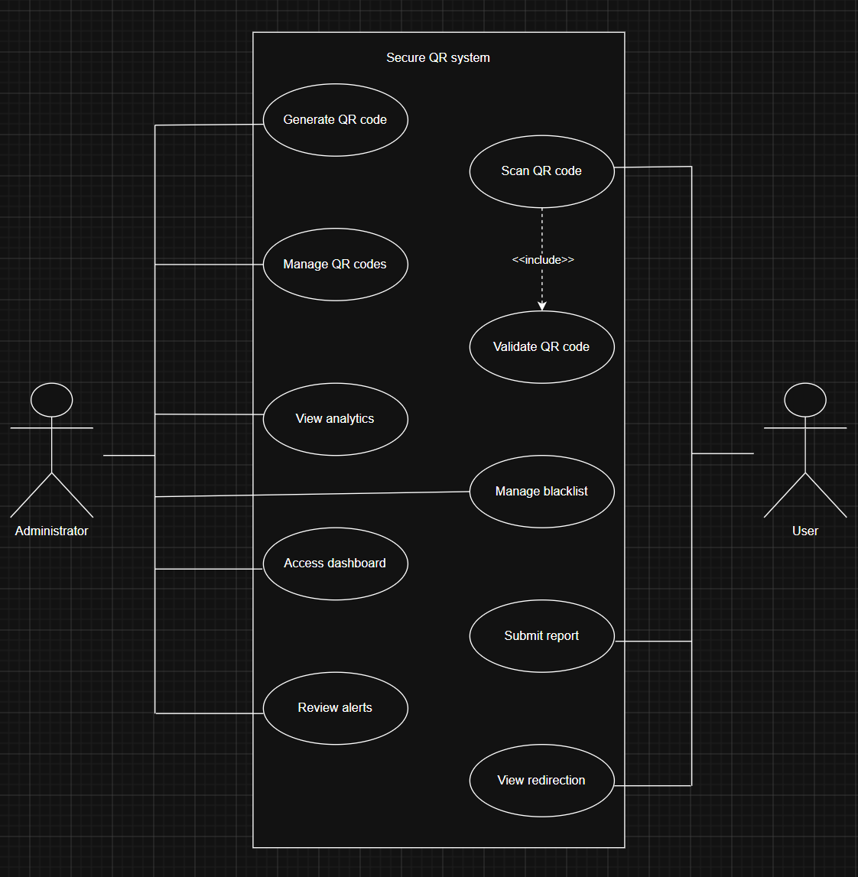

ERD Diagram

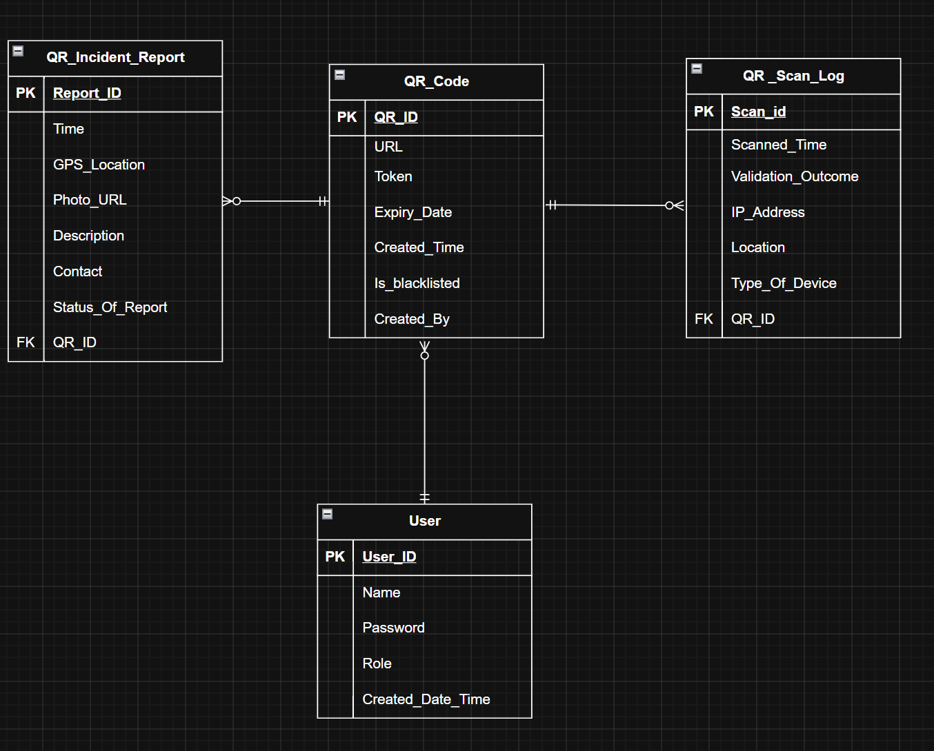

Context Diagram
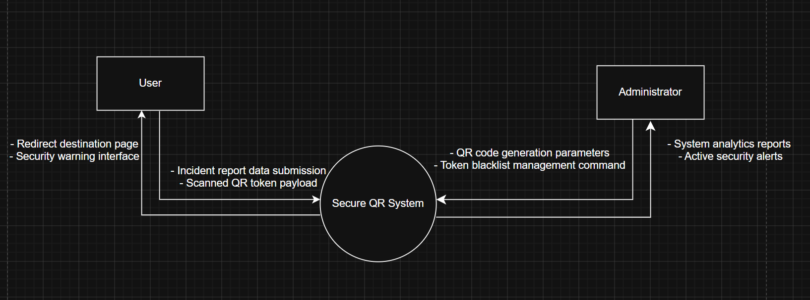

Main Operational System
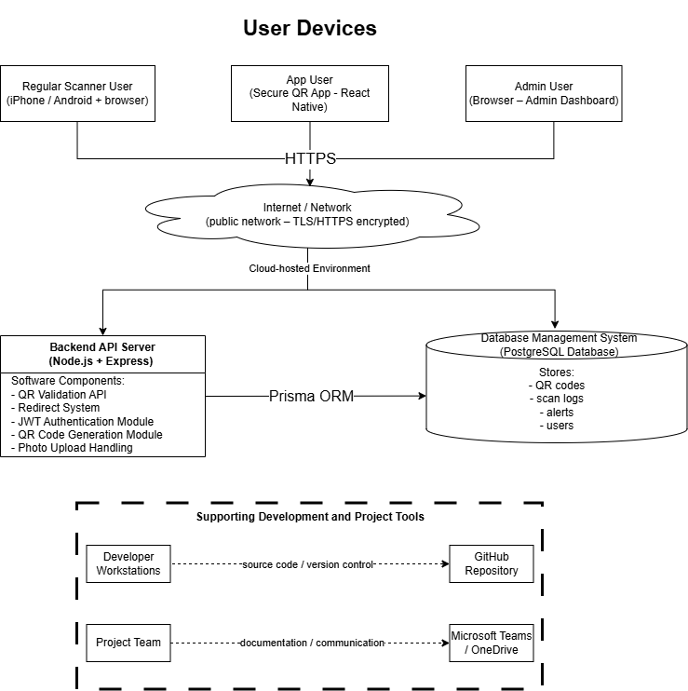

Conclusion
This Requirements and Analysis document has presented the business problem, project goals, system requirements, and the suggested system for solving the Secure QR Code Development project. The suggested system offers secure QR code creation, verification, monitoring, and detecting tampering functionalities to overcome the security weaknesses associated with conventional QR codes.
The collected requirements will serve as a solid starting point for the design, development, testing, and deployment process of the system. The successful completion of the project will result in improved security of QR codes.

Appendices

Appendix A – Deliverable Task Breakdown Statement (signed, scanned and inserted into document)
Deliverable Name:
Project Team Name | Team Number
VAFPQR | FT02

Name | Student ID | Deliverable Percentage Completed | Signature | Date
Patricia Mikaela Marie Jusay Orenza | 35235647 | 10% |  | 8 June 2026
Lim Yu Jun Felixia | 35544256 | 18% |  | 8 June 2026
Roy Yoo Hojin | 34845454 | 18% |  | 8 June 2026
Gu QiYu | 35139306 | 18% |  | 8 June 2026
Alvin Rui Long Yeow | 35475756 | 18% |  | 8 June 2026
Vanessa Tan | 35235647 | 18% |  | 8 June 2026

Appendix B - Copies of client documents on which you based the analysis.
Word Document:
ICT302 Secure QR Code Development TM 2026
Client:
- Peter Cole
- Mike Groeneweg

Appendix C – Glossary
Term | Definition
API (Application Programming Interface) | A set of policies and guidelines enabling the interaction and exchange of information among various software programs.
Authentication | The procedure of checking the validity and authentication of a QR code, user, or system component prior to granting access to the resource.
Backend | The back-end application of the system processing user requests, managing data, and executing validation procedures.
Blacklist | An enumeration of the QR codes that have become invalid, compromised, expired, or unsafe.
Dashboard | The web dashboard for tracking events in the system, handling QR codes, alerts, and monitoring analytics.
Database | A collection of data used for the storage of QR code information, user information, scan logs, and tampering incidents.
Expiry Date | The date after which a QR code will become invalid, unable to pass through the authentication procedures.
GPS (Global Positioning System) | A GPS-like location service used to establish the geographical coordinates of the user's mobile phone.
HTTPS (Hypertext Transfer Protocol Secure) | The protocol for securing data transmission between users and the server.
JWT (JSON Web Token) | The method of securely transmitting tokens carrying user information between system components.
Mobile Application | The Android program created for scanning QR codes and logging tampering incidents.
QR Code (Quick Response Code) | A two-dimensional barcode that carries information encoded into it for scanning by users.
QR Code Authentication | Process by which authenticity of a QR code is checked and ensured that it hasn't expired or gone through modification or blacklist.
Redirect System | An element used to direct the user to a destination website URL upon successful QR code verification.
Scan Log | A database storing data on scanning QR codes, consisting of date, time, location, and device information.
Telemetry | System information on the usage of QR codes and scanning activities conducted.
Tampering Report | A feedback report provided by the users in case QR codes seem suspicious, damaged, modified, or fake.
URL (Uniform Resource Locator) | The web address where users would be directed by a QR code after verifying successfully.
UUID (Universally Unique Identifier) | A special number created by the system to make every single QR code unique.
Validation | Checking the legitimacy of the scanned QR codes based on the required criteria, including expiration and being blacklisted.
Version Control | A tool used to track and manage modifications in the source code and project documents.
GitHub | Cloud-based services used by the development team for management and versioning of source codes and project documents.
OneDrive | Microsoft's cloud services utilized by the development team for collaboration in terms of source codes and documents.
User Acceptance Testing (UAT) | A type of testing carried out by stakeholders or users to see if the solution fulfills their business needs.
Secure QR Code System | The final solution implemented in this project for handling QR codes.

